
QUALITY ALERT

Customer: ChamClad Date: October 01, 2023
Die: 15766 Customer NCR:
Type of Complaint: ChamClad REJECT

Description: ChamClad REJECTED – Material has wall LEG was CROOKED/MOVING.
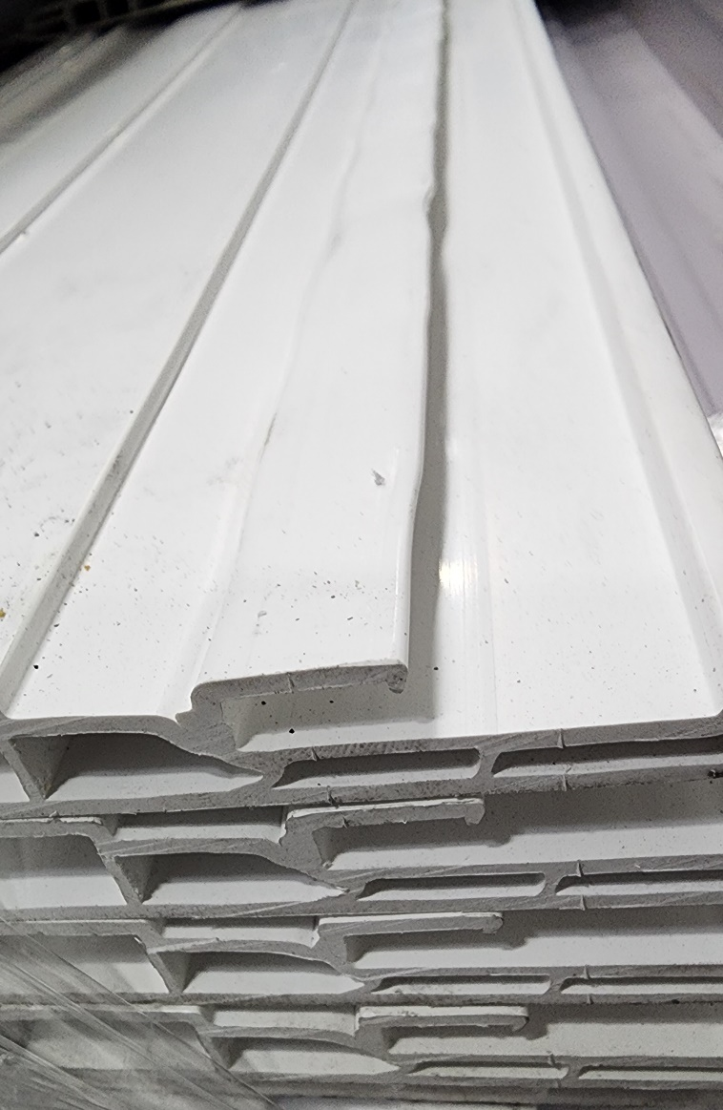
PLEASE CHECK CAREFULLY AND
MAKE SURE BAD MATERIAL NOT PACK INTO BUGGY

BY SIGNING BELOW, YOU ACKNOWLEDGE THE PROBLEM ABOVE AND AGREE TO MONITOR THIS ISSUE IN FUTURE PRODUCTION RUNS.
DAY SHIFT |  | AFTERNOON SHIFT |  | NIGHT SHIFT
NAME | SIGNATURE | NAME | SIGNATURE | NAME | SIGNATURE

